Soil Texture exercise

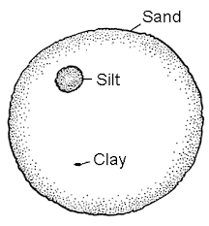
Sand _______________mm
Silt ________________mm
Clay _______________mm

1. Using the soil textural triangle, what is the soil texture of a soil containing 65 percent sand and 10 percent clay? What is the percent silt in this soil?

2. Using the soil textural triangle, what is the soil texture of a soils containing 18 percent sand and 30 percent clay? What is the percent silt in this soil?

3. Using the soil textural triangle, what is the soil texture of a soils containing 35 percent sand and 45 percent clay? What is the percent silt in this soil?

Identify the soil texture for each sample:
1.
2.
3.
4.
5.
6.

