Soil information to study for the CO Environthon.

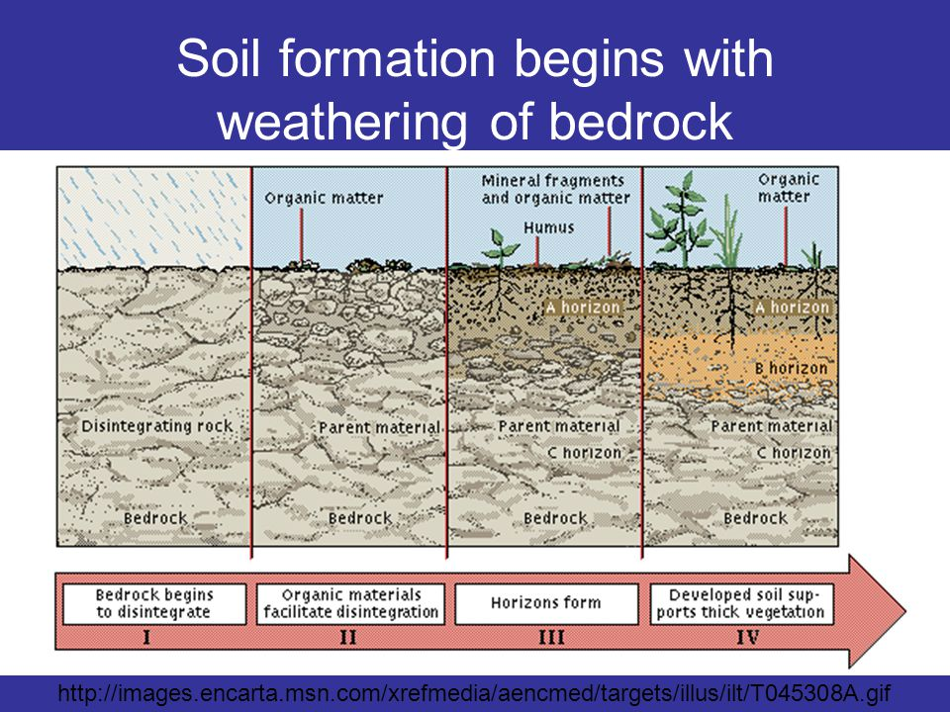

Look at this slide. What factors and processes are acting on each section? What factors and processes cause the soil to move to the next section?
Soil properties. Look for soil forming factors and processes going on in this video.

Take these two quizzes.
http://forces.si.edu/soils/ Hidden Horizons Puzzle, Big Picture Game

https://www.youtube.com/watch?v=US9rSig0LHE
5 soil forming factors
High OM in prairie/grasslands and forests
Soils are different on different landforms
E horizon – not high in clay, light colors, lower OM, coarser texture than B horizon below it

https://www.youtube.com/watch?v=3Dnf2e1i9Ag
4 soil forming processes
Translocation = transports up/down in the profile, agents are water and organisms

