Introduction
Increased climate variability, including increased temperatures and evaporative demand, extended growing season, variable precipitation, and more frequent and intense drought events, is projected for the southwestern Great Plains where rangeland is the major land use. Rangelands represent diverse arid and semiarid systems defined by low plant productivity, high precipitation variability and frequent drought (an extended period of relatively low precipitation). There are approximately 770 million acres of rangelands in the United States making up approximately 31% of the total land area and approximately 65% of the total land area in Colorado. Understanding the limitations of the land is necessary to conserve rangelands and the services they provide. Ecological site (ES) descriptions developed by the USDA provide land owners with recommended management strategies based on site potential and can be used to help reduce the effects of climate variability at the local level. Ecological site concepts are uniquely developed within individual Major Land Resource Areas (MLRA).
MLRA 69 is located in the Upper Arkansas Valley Rolling Plains of southeastern Colorado and covers approximately 7.6 million acres across 13 counties (Figure 1). Approximately 80% of the MLRA consists of grazing lands dominated by shortgrass prairies. Most rangelands are grazed by cattle and depending on soil properties, growing conditions and previous management the stocking rate recommendation ranges from 1.83 acres/animal unit months (AC/AUM) to 24.33 AC/AUM. MLRA 69 consists of 19 ES’s that have been combined for this report into 7 groups based on similar management and disturbance responses.
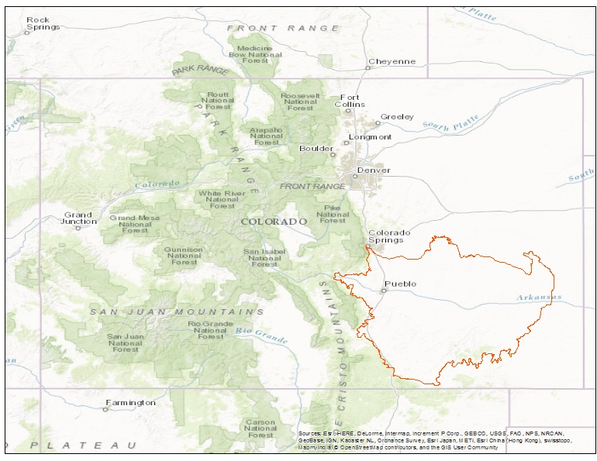
Figure 1. Major Land Resource Area 69

Exposure
Precipitation events in the Southwestern Great Plains are typically short where much of the moisture is evaporated and soils maintain a low soil water content. Most of the moisture received in the MLRA 69 is received in spring and summer where the average precipitation ranges from 102-127 mm in May through September. Thunderstorms are common which can lead to flash flooding and hail storms. Climate models predict a slight increase in mean annual precipitation for MLRA 69, however, increasing mean annual temperatures and potential evapotranspiration will lead to drier conditions for the area. Warmer temperatures result in more days above freezing leading to a longer growing season (Abatzoglou, 2017) and greater abundance of warm season grasses (Epstein et al., 2002). The structure and function of the shortgrass steppe ecosystem in MLRA 69 is dependent on precipitation, grazing and fire (Pielke et al., 2005; Rondeau et al., 2013), therefore understanding the response of vegetation to the changing climate will aid in drought management.

Sensitivity
Knowledge of factors that drive and regulate ecological systems are needed in order to understand and predict response to drought. Applying the vulnerability assessment framework within the context of an Ecological Site State and Transition Models (STMs) help us better understand potential impacts and what are the best management strategies for each ecological site. The ESs within MLRA 69 (Table 1) differ in production, response to disturbance, management and ability to recover post-disturbance. The ecological sites are grouped based on landform position and the vulnerability classes derived in this study (low, moderate, or high) are primarily based on landform position, production, rooting depth, soil depth, salt content, land use, soil texture, available water capacity, rock or other fragments and aspect.

Table 1. MLRA 69 Ecological Site Class Drought Vulnerability Classes (based on reference community).
Ecological Site Groups |  |  | Ecological Sites
Breaks |  |  | Limestone Breaks |  |  | Sandstone Breaks |  |  | Gravel Breaks
Soft Breaks |  |  | Gypsum Breaks |  |  | Shale Breaks
Sandy Upland |  |  | Choppy Sands |  |  | Deep Sand |  |  | Sandy Plains
Saline Upland |  |  | Salt Flat |  |  | Sandy Salt Flat |  |  | Alkaline Plains
Loamy Upland |  |  | Loamy Plains |  |  | Clayey Plains |  |  | Shaly Plains
Lowland |  |  | Salt Meadow |  |  | Sandy Bottomland |  |  | Saline Overflow
Depressions |  |  | Plains Swale |  |  | Saline Plains Swale
low |  | moderate |  |  | high

Potential Impact
In MLRA 69, total annual production is highly dependent on the distribution of precipitation and its effects on soil moisture. During droughts, total annual production declines, affecting grazing management decisions. In addition to the effects of livestock grazing, droughts are important ecological drivers, significantly influencing the composition and distribution of rangeland plant communities. Severe drought can lead to local extirpation in areas where the recolonization potential of the site is low (Samson et al., 2004). Both abiotic (Ecological Site) and biotic (ecological state) can define how a site will respond to drought. Although heavy grazing can influence plant community dynamics, climate variability has a greater effect on plant community and productivity in arid and semi-arid environments (Biondini et al., 1998). Changes in amount, intensity, and frequency of precipitation events may also affect the potential for invasions, as species that are better adapted to an altered climate may have an advantage over native vegetation (Mack et al., 2000). The reduction in vegetative cover may lead to wind and water erosion as well as increase occurrence and intensity of wildfires, insect outbreaks, and invasion of non-native plant species.

Adaptive Capacity
Management actions to adapt to projected shifts in climate can mitigate the ecological and socio-economic impacts on rangeland systems. Adaptive management should include flexibility to minimize the effects of a natural disaster at multiple levels; enterprise or management level, ecological level and the human/social level. Willingness to change enterprise structure such as shifting from livestock production to ecotourism, hunting, or wind energy may be necessary if the traditional operation is no longer economically viable (Joyce et al., 2013). One of the most important adaptive strategies in rangelands is to allow adequate rest and recovery of vegetation. In normal years in Colorado, 30-45 days is recommended during May and June and 60-90 days during July-October for a pasture to recover after grazing. More recovery days are necessary during drought years (Cook et al., 2017). The time needed for adequate regrowth depends on plant species (cool vs warm season), climate, soil moisture and time of year. Plants should not be grazed during the dormant season and grazing should be delayed until plants reach minimum grazing heights. Reducing stocking rate is the most important adaptive strategy when coping with drought in rangelands as overgrazing can result in desirable forages being replaced by undesirable weeds. Another way to adapt to elevated temperatures and reduced precipitation is changing cattle to a more heat tolerant breed such as Brahman or changing livestock species (from cattle to sheep/goats) to minimize forage uptake. Providing shade and minimizing distance between water sources is also recommended as a way to alleviate heat stress on livestock. Being able to adapt to a changing climate involves constantly monitoring weather conditions and patterns as weather varies from region to region and across rangelands. Being aware of the rangeland condition and ecological site’s sensitivity to drought can mitigate the effects of drought at a site specific level. Incorporating enterprise, ecological and social/human organization strategies into an adaptive management plan will mitigate the effects of drought which is critical to the social and ecological stability in the region.

References
Abatzoglou, J., 2017. AgClimate Atlas [WWW Document]. URL climate.northwestknowledge.net (accessed 3.16.17).
Biondini, M.E., Patton, B.D., Nyren, P.E., 1998. Grazing Intensity and Ecosystem Processes in a Northern Mixed-Grass Prairie, Usa. Ecological Applications 8, 469–479. https://doi.org/10.1890/1051-0761(1998)008[0469:GIAEPI]2.0.CO;2
Cook, J., Nosal, D., Bokan, S., Rizza, J., Lockard, E., 2017. Dryland Pasture Condition Assessment and Guidelines for Colorado Small Acreages [WWW Document]. URL https://extension.colostate.edu/docs/sam/grazing-guide.pdf (accessed 8.2.17).
Epstein, H.E., Burke, I.C., Mosier, A.R., 1998. Plant Effects on Spatial and Temporal Patterns of Nitrogen Cycling in Shortgrass Steppe. Ecosystems; New York 1, 374–385. https://doi.org/http://dx.doi.org/10.1007/s100219900031
Epstein, H.E., Gill, R.A., Paruelo, J.M., Lauenroth, W.K., Jia, G.J., Burke, I.C., 2002. The relative abundance of three plant functional types in temperate grasslands and shrublands of North and South America: effects of projected climate change. Journal of Biogeography 29, 875–888. https://doi.org/10.1046/j.1365-2699.2002.00701.x
Mack, R.N., Simberloff, D., Mark Lonsdale, W., Evans, H., Clout, M., Bazzaz, F.A., 2000. Biotic Invasions: Causes, Epidemiology, Global Consequences, and Control. Ecological Applications 10, 689–710. https://doi.org/10.1890/1051-0761(2000)010[0689:BICEGC]2.0.CO;2
Pielke, R.A., Doesken, N., Bliss, O., Green, T., Chaffin, C., Salas, J.D., Woodhouse, C.A., Lukas, J.J., Wolter, K., 2005. Drought 2002 in Colorado: An Unprecedented Drought or a Routine Drought? Pure appl. geophys. 162, 1455–1479. https://doi.org/10.1007/s00024-005-2679-6
Rondeau, R.J., Pearson, K.T., Kelso, S., 2013. Vegetation Response in a Colorado Grassland-shrub Community to Extreme Drought: 1999–2010. The American Midland Naturalist 170, 14–25. https://doi.org/10.1674/0003-0031-170.1.14
Samson, F.B., Knopf, F.L., Ostlie, W.R., 2004. Great Plains ecosystems: past, present, and future. Wildlife Society Bulletin 32, 6–15. https://doi.org/10.2193/0091-7648(2004)32[6:GPEPPA]2.0.CO;2

**Additional pictures depending on available space….

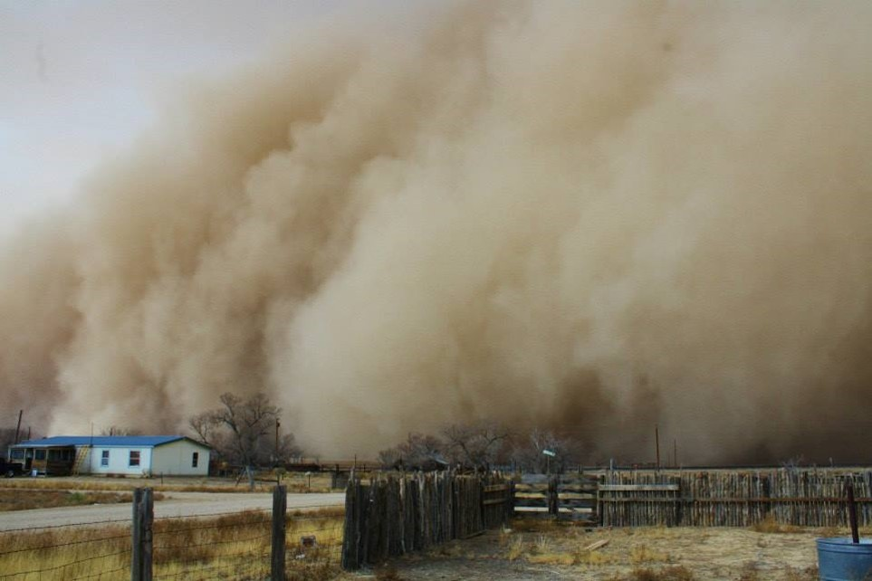
Figure 9. Dust storm during the 2014 drought in Otero County, Colorado located within MLRA 69.
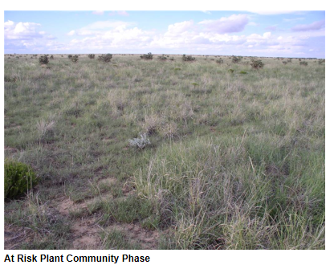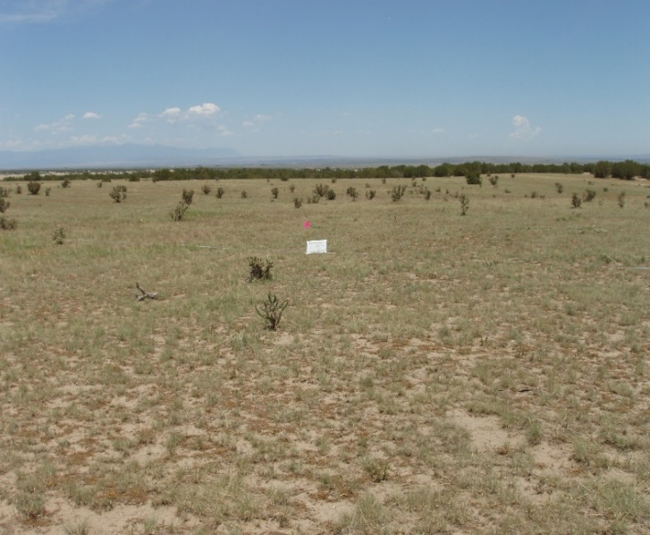
Figure 11. Loamy Plains Ecological Site: a) at risk community and b) short grass dominated state. Photo courtesy of Kimberly Diller, NRCS-Colorado.

